Lesson 3: Viết đoạn văn xu hướng
CÓ 2 LOẠI TỪ NỐI:
- TỪ NỐI 2 VẾ TRONG 1 CÂU (NGĂN CÁCH NHAU BỞI DẤU PHẨY)
- TỪ NỐI 2 CÂU (NGĂN CÁCH NHAU BỞI DẤU CHẤM)
(1) TỪ NỐI GIỮA HAI MỆNH ĐỀ TRONG MỘT CÂU
A. Time (từ nối chỉ thời gian)
Cấu trúc
- After V-ing / Noun phrase, Clause 2
- Clause 1 before V-ing / Noun phrase
- Clause 1, and then Clause 2
- Clause 1, which then + V2/ed
Ví dụ 1:
Câu 1: the number of students studying abroad from China remained unchanged at 5 from 2000 to 2010.
Câu 2: there was a dramatic increase from 5 to 90 in this figure between 2010 and 2015

After | After remaining unchanged at 5 from 2000 to 2010, the number of students studying abroad from China increased dramatically from 5 to 90 between 2010 and 2015
Before | The number of students studying abroad from China remained unchanged at 5 from 2000 to 2010 before increasing dramatically to 90 between 2010 and 2015
And then | the number of students studying abroad from China remained unchanged at 5 from 2000 to 2010, and then there was a dramatic increase from 5 to 90 in this figure between 2010 and 2015
Which then | The number of students studying abroad from China remained unchanged at 5 from 2000 to 2010, which then increased dramatically to 90 between 2010 and 2015

Ví dụ 2:

The percentage of tourists visiting the Castle increased significantly from around 23% to 40% between 1980 and 1990. This figure peaked at 45% in 1995

Linh | Anh Nam
After increasing significantly from around 23% to 40% between 1980 and 1990, the percentage of tourists visiting the Castle peaked at 45% in 1995. | The percentage of tourists visiting the Castle increased significantly from around 23% to 40% between 1980 and 1990, and then this figure peaked at 45% in 1995  After increasing significantly from around 23% to 40% between 1980 and 1990, the percentage of tourists visiting the Castle peaked at 45% in 1995

B. Contrast (từ nối chỉ sự tương phản)
Cấu trúc
- While / Whereas Clause 1, Clause 2
- Clause 1, but Clause 2
- Despite V-ing / Noun phrase, Clause 2 (mặc dù)
Lưu ý
- “After”, “Before”, “While/Whereas”, “Despite”: đứng đầu hoặc giữa câu.
- “And” và “But”: chỉ đứng giữa câu.
Ví dụ
The percentage of visitors to the Castle increased significantly to 45% in 1995. This figure decreased remarkably to under 35% at the end of the period.
- While the percentage of visitors to the Castle increased significantly to 45% in 1995, this figure decreased remarkably to under 35% at the end of the period.  - The percentage of visitors to the Castle increased significantly to 45% in 1995, but this figure decreased remarkably to under 35% at the end of the period.  - Despite increasing significantly to 45% in 1995, the percentage of visitors to the Castle decreased remarkably to under 35% at the end of the period. | Whereas the percentage of visitors to the Castle increased significantly to 45% in 1995, this figure decreased remarkably to under 35% at the end of the period.  The percentage of visitors to the Castle increased significantly to 45% in 1995, but this figure decreased remarkably to under 35% at the end of the period  Despite increasing significantly to 45% in 1995, the percentage of visitors to the Castle decreased remarkably to under 35% at the end of the period  Despite a significant increase to 45% in 1995, the percentage of visitors to the Castle decreased remarkably to under 35% at the end of the period

(2) TỪ NỐI GIỮA HAI CÂU
A. Time (từ nối chỉ thời gian)
- Sentence 1. Then, Sentence 2.
- Sentence 1. Following that, Sentence 2.
- Sentence 1. After that, Sentence 2.
Ví dụ:
• Sentence 1: The number of people using buses increased moderately to 500 in 2010.
• Sentence 2: It decreased slowly to 400 in 2015.

The number of people using buses increased moderately to 500 in 2010. After that, it decreased slowly to 400 in 2015. | The number of people using buses increased moderately to 500 in 2010. Following that, it decreased slowly to 400 in 2015.

B. Contrast (từ nối chỉ tương phản)
- Sentence 1. However, Sentence 2. (Với điều kiện S của câu 1 cũng là S của câu 2 => cùng đối tượng)
- Sentence 1. In contrast / By contrast, Sentence 2. (khác đối tượng; S câu 1 khác S câu 2 => dùng khi bắt đầu đổi từ đối tượng này sang đối tượng khác)
Ví dụ:
Bài tập 1 (Cùng chủ ngữ - dùng "However"):
- Sentence 1: The price of oil rose sharply to $100 per barrel in January.
- Sentence 2: It declined slightly to $80 for the next three months.
=> The price of oil rose sharply to $100 per barrel in January. However, it declined slightly to $80 for the next three months.
Bài tập 2 (Khác chủ ngữ - dùng "In contrast"):
- Sentence 1: The amount of water used in London increased to 150 litres per day.
- Sentence 2: The figure for Paris decreased to only 100 litres per day.
=> The amount of water used in London increased to 150 litres per day. By contrast, the figure for Paris decreased to only 100 litres per day.
C. Similarity (từ nối chỉ tương đồng) - Khác chủ ngữ (đổi đối tượng)
- Sentence 1. Similarly, Sentence 2.
- Sentence 1. Likewise, Sentence 2.
Ví dụ
• Sentence 1: The percentage of households with a car rose steadily to 70% in 2005.
• Sentence 2: The proportion of families with a motorbike also went up gradually to 85%.

The percentage of households with a car rose steadily to 70% in 2005. Similarly, the proportion of families with a motorbike also went up gradually to 85%. | The percentage of households with a car rose steadily to 70% in 2005. Likewise, the proportion of families with a motorbike also went up gradually to 85%.

D. Không tương đồng cũng không tương phản
- Sentence 1. Meanwhile, Sentence 2.
Ví dụ:
• Sentence 1: The number of people playing football increased to 2,000 people.
• Sentence 2: The number of people playing tennis remained the same at 500 people.

The number of people playing football increased to 2,000 people. Meanwhile, the number of people playing tennis remained the same at 500 people. | The number of people playing football increased to 2,000 people. Meanwhile, the number of people playing tennis remained the same at 500 people.

KHI BÁO CÁO SỐ LIỆU, NẾU SỐ LIỆU CHƯA CHẠM VÀO MỘT MỐC SỐ TRÒN:
· about (khoảng)
· around (xấp xỉ / khoảng)
· approximately (khoảng / xấp xỉ — trang trọng hơn)
· roughly (xấp xỉ / ước chừng)
· nearly (gần / gần như)
· almost (hầu như / gần như chạm đến)
· just under (ngay dưới / thấp hơn một chút)
· just over (ngay trên / cao hơn một chút)

Practice
Sử dụng từ nối để viết thành một đoạn văn hoàn chỉnh
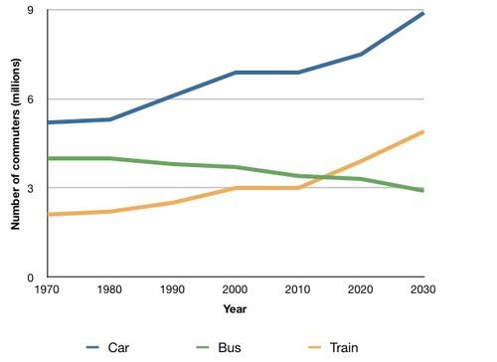
In 1970, around 5 million UK people travelled by car, (1) which then increased moderately to 7 million in 2000. (2) After that, it is predicted that this figure will reach 9 million in the year 2030.
(3) Similarly, the number of rail passengers was approximately 2 million in 1970. (4) Following that, there was a minimal rise to 3 million in 2000. (5) Then, the prediction is that this figure will grow considerably to 5 million in 2030.
(6) In contrast, the figure for the bus started at 4 million in 1970. (7) After that, there was a slight decrease to 3.5 million in 2000. (8) Following that, this figure is anticipated to drop minimally to 3 million in 2030.

Linh | Anh Nam
which then | which then
after that | Following that
Likewise | Similarly
Then | After that
Following that | Then
In contrast/ By contrast | In contrast
Then | After that
After that | Then

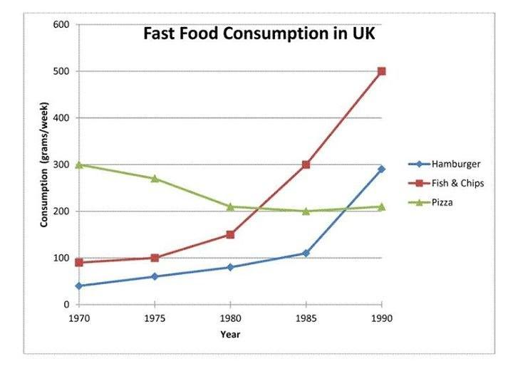

In 1970, the amount of pizza consumption was 300 grams per week, (1) which then fell moderately to 200 grams in the next ten years. (2) After that, there was a stability at 200 grams from 1980 to 1990.
(3) In contrast, the quantity of fish & chips consumed started at 100 grams in 1970. (4) Then, it rose slightly to 150 grams over the following ten-year period. (5) Following that, the period between 1980 and 1990 showed a dramatic increase to 500 grams.
(6) Similarly, the figure for hamburger grew minimally from 50 grams to just under 100 grams in the period from 1970 to 1980. (7) After that, this number went up significantly to 300 grams in the year 1990.

Practice 2: Viết thành đoạn văn hoàn chỉnh

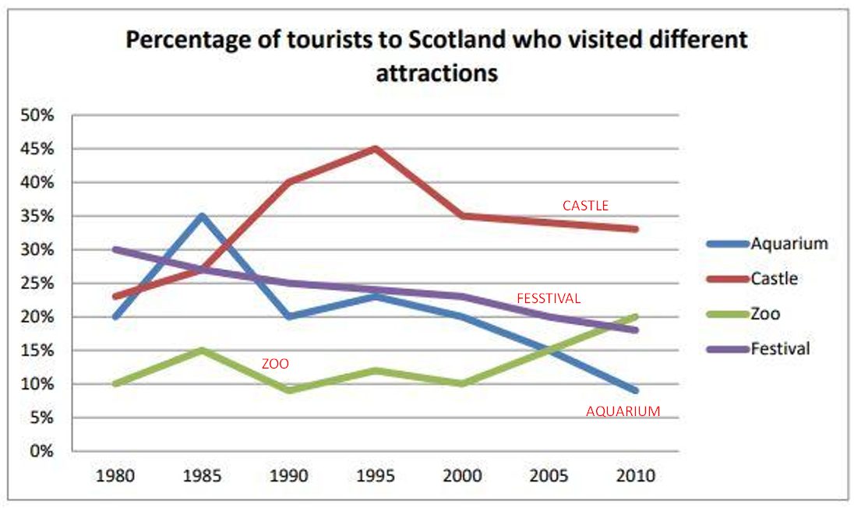
S: The percentage of tourists coming to / travelling to / visiting + địa điểm
S: The proportion of visitors to + địa điểm
Câu đầu tiên của đoạn: In + năm đầu, S was / started at + số liệu năm đầu, which then …
Linh | Anh Nam
In 1980, the percentage of tourists coming to castle was at about 23%, which then rose considerably and peaked at 45% in1995. However, it experienced a moderate fall to 35% in 2000. After that, this figure reduced slightly to roughly 33% at the end of period./ However, after falling moderately to 35% in 2000, this figure reduced slightly to roughly 33% at the end of period. Meanwhile, there was a gradual decrease from 30% to around 18% in the figure for festival throughout the period.  The proportion of visitors to aquarium increased substantially from 20% to 35% in the first five years before going down / reducing back to 20% from 1980 to 1990. Following that, despite rising slightly to 23% in 1995, this figure recorded a remarkable drop to approximately 9% at the end of the period. In contrast, the percentage of tourists travelling to zoo saw a fluctuation between 8% and 15% in the first 20 years, which then grew remarkably to 20% in 2010. | In 1980, the percentage of tourists travelling to castle started at approximately 23%, which then increased significantly to peak at 45% in 1995 / to a peak of 45% in 1995. However, there was a gradual decrease to 35% in this figure in 2000 before falling to nearly 33% at the end of the period. Meanwhile, the figure for festival recorded a gradual reduction from 30% to roughly 18% over the period.  The proportion of visitors to aquarium experienced a rapid growth from 20% to 35%  between 1980 and 1985 before reducing sharly to 20% over the next five years. After that, despite increasing marginally to roughly 24% in 1995, this figure recorded a significant decline to just under 9% at the end of the period. By contrast, the figure for zoo witnessed a fluctuation between around 10 and 15% over the first 20 years before a remarkable rise to 20% at the end of the period.



Aquarium (thuỷ cung)

Castle (lâu đài)

Zoo

Festival

PRACTICE 3 - HOMEWORK
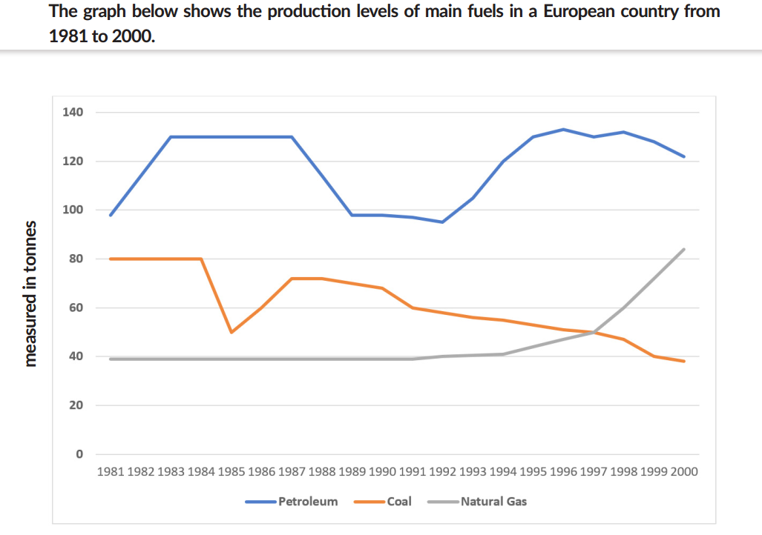
  - Petroleum:
  - Coal:

  - Natural Gas:

\

